RESUME

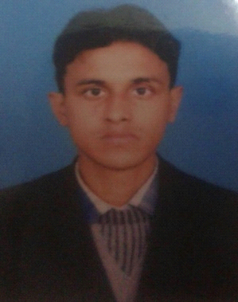DIWAN SADDAM HUSSAIN
Email:diwan.saddamhussain@gmail.com
Contact: 9871843028

Objective:

To work with maximum potential in a challenging and dynamic environment, with an opportunity of working with diverse group of people and enhancing my professional skills with learning and experience for career growth.

Educational Qualifications:

Name of Examination | University/ Board | Name of College/ School | Year of  Passing | Performance (CGPI/%) | Class Obtained
B.E | ANNAMLAI UNIVERSITY | ANNAMALAIUNIVERSITY | 2015 | 60.6 | second
12th | BSEB PATNA | INTER COLLEGE BHABUA | 2010 | 62.6 | First
10th | BSEB PATNA | INTER COLLEGE BHABUA | 2008 | 52.6 | second

Computer Skills:

Operating System: Windows7, 8/10/XP/Vista
Packages: MicrosoftOffice2010, 2013
Software: AUTOCAD

Academic Project:

Major Project: | Solar water purification by using thermal method
Training:

- KANTI BIJLEE UTPADAN NIGAM( MUJAFFAR BIHAR)
- HVAC DESIGN AND DRAFTING From MEP center Delhi (NSDC)
- SOFTWARE USED: AutoCAD2013,McQuay Duct size

- Project summary: Heat load calculation by the ASHRAE $ISHRAE standards Heat load calculation by E-20Excel sheet, piping size calculation for chiller, AHU capacity, Pump Head calculation, installation of AHU, Estimation of BOQ $Duct Design and Drafting (SLD $DLD) for whole building on AUTOCAD

Strengths:

- Good Leadership quality
- Fast learner - Ambitious

Personal Detail:

- Name : Diwan saddam hussain
- Father Name : Diwan muzaffar khan
- Date Of Birth : 02 Jan 1994
- Email Id : diwan.saddamhussain@gmail.com
- Contact no : +919871843028

Passport Detail:

- Passport no : M6963063
- Place of Issue : Patna
- Date of Issue : 27/02/2015
- Date of Expiry : 26/02/2025

Declaration:

I, hereby confirm that the above information is true and correct up to my knowledge and belief

Place: Delhi
Date: 15/09/2017 DIWAN SADDAM HUSSAIN

